Azure Application Gateway with Path-Based Routing (Portal-Based)

1. Objective
Design and deploy an Azure Application Gateway (Layer 7 Load Balancer) that supports path-based routing using the Azure Portal.
Traffic routing rules: - /product → VM1 (Apache – Product App) - /cart → VM2 (Apache – Cart App)
The solution includes: - Secure Virtual Network (VNet) design - Dedicated subnets for Application Gateway and VMs - Network Security Groups (NSGs) for traffic control - End-to-end testing and validation

2. Architecture Overview
High-Level Flow: Client → Application Gateway (Public IP) → Backend VM (based on URL path)
Components Used: - Azure Application Gateway (Standard_v2 or WAF_v2) - 2 Ubuntu VMs with Apache Web Server - Virtual Network with 3 Subnets - Network Security Groups (NSG)

3. Network Design

3.1 Virtual Network
Component | Value
VNet Name | agw-vnet
Address Space | 10.0.0.0/16

3.2 Subnets
Subnet Name | Address Range | Purpose
agw-subnet | 10.0.0.0/24 | Application Gateway (Mandatory)
product-subnet | 10.0.1.0/24 | Product VM
cart-subnet | 10.0.2.0/24 | Cart VM
⚠️ Application Gateway must be in its own dedicated subnet.

4. Network Security Groups (NSG)

4.1 NSG Rules

NSG for Application Gateway Subnet
Priority | Rule | Port | Source | Action
100 | Allow-HTTP | 80 | Internet | Allow

NSG for VM Subnets
Priority | Rule | Port | Source | Action
100 | Allow-HTTP-from-AGW | 80 | AGW Subnet | Allow
110 | Allow-SSH | 22 | Admin IP | Allow
4096 | Deny-All | * | * | Deny

5. Virtual Machine Setup (Apache)

5.1 VM Configuration (Both VMs)
Setting | Value
Image | Ubuntu 20.04 LTS
Size | Standard B1s
Public IP | Not Required (Optional for testing)
Authentication | Password / SSH

5.2 Apache Installation (Using Custom Script Extension)

Product VM (VM1)
sudo apt update -y
sudo apt install apache2 -y
echo "<h1>Product Page</h1>" | sudo tee /var/www/html/product/index.html

Cart VM (VM2)
sudo apt update -y
sudo apt install apache2 -y
echo "<h1>Cart Page</h1>" | sudo tee /var/www/html/cart/index.html

6. Application Gateway Configuration

6.1 Create Application Gateway
Azure Portal → Create Resource → Networking → Application Gateway
Basic Settings: - SKU: Standard_v2 or WAF_v2 - Instance Count: 2 - VNet: agw-vnet - Subnet: agw-subnet - Public IP: Create new

6.2 Backend Pools
Backend Pool Name | Target
product-backend | Product VM Private IP
cart-backend | Cart VM Private IP

6.3 Health Probes
Probe | Path | Port
product-probe | / | 80
cart-probe | / | 80

6.4 HTTP Settings
Setting | Value
Protocol | HTTP
Port | 80
Cookie-based Affinity | Disabled
Timeout | 20s

6.5 Path-Based Routing Rule
Create a Routing Rule → Path-based
Path | Backend Pool
/product/* | product-backend
/cart/* | cart-backend
Listener: - Frontend IP: Public IP - Protocol: HTTP - Port: 80

7. Testing & Validation

7.1 Test URLs
URL | Expected Result
http:///product | Product Application Page
http:///cart | Cart Application Page

7.2 Health Verification
- Application Gateway → Backend Health
- Status should show Healthy for both VMs

8. Security Best Practices
- Use WAF_v2 for production
- Restrict SSH to Admin IP only
- Disable Public IP on VMs
- Use HTTPS with SSL Certificates
- Enable Azure Monitor & Diagnostic Logs

9. Key Takeaways
- Application Gateway enables Layer 7 routing
- Dedicated subnet for AGW is mandatory
- Path-based routing allows microservice-style architecture
- NSGs provide subnet-level security
- Apache backend validates real-time routing

10. Use Cases
- E-commerce platforms (product/cart separation)
- Microservices routing
- Blue-green deployments
- API version routing

11. Screenshots Required (Step-by-Step Capture Guide)
Use this section as a submission checklist. Capture each screen from the Azure Portal exactly as listed.

Step 1: Resource Group
Path: Azure Portal → Resource groups → Create - Capture: Resource group name, region
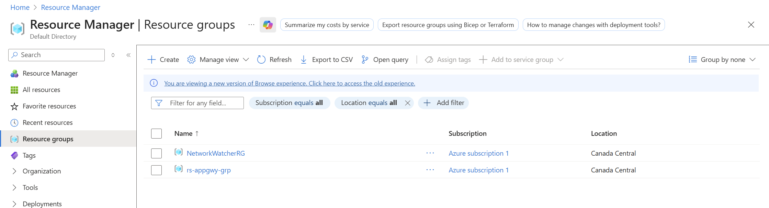

Step 2: Virtual Network Creation
Path: Azure Portal → Virtual networks → Create - Capture: Address space (10.0.0.0/16)
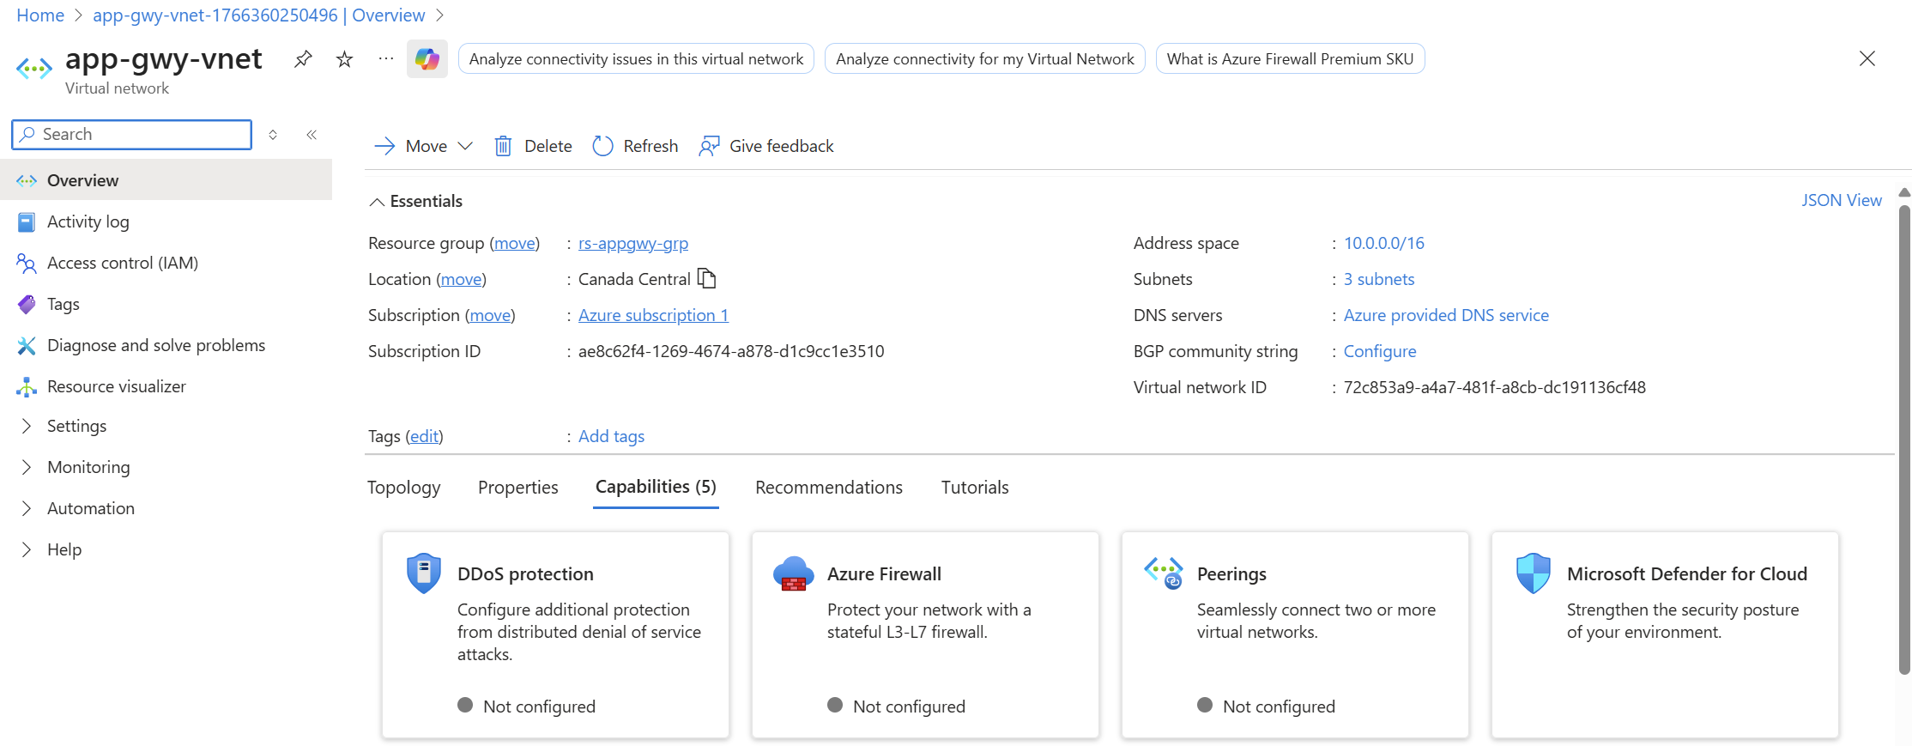

Step 3: Subnets Configuration
Path: Virtual network → Subnets - Capture: - agw-subnet (10.0.0.0/24) - product-subnet (10.0.1.0/24) - cart-subnet (10.0.2.0/24)
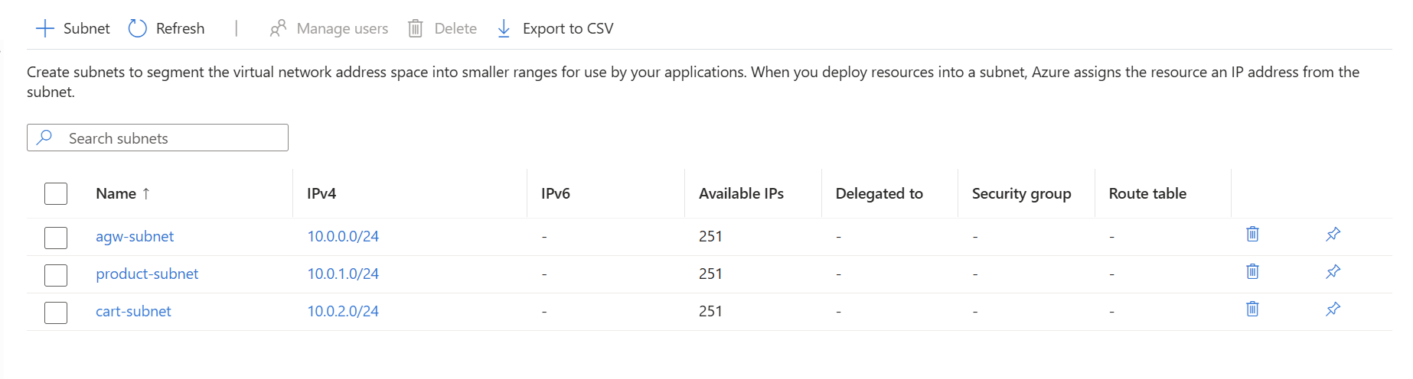

Step 4: NSG Creation
Path: Network security groups → Create - Capture: NSG names and associated subnets
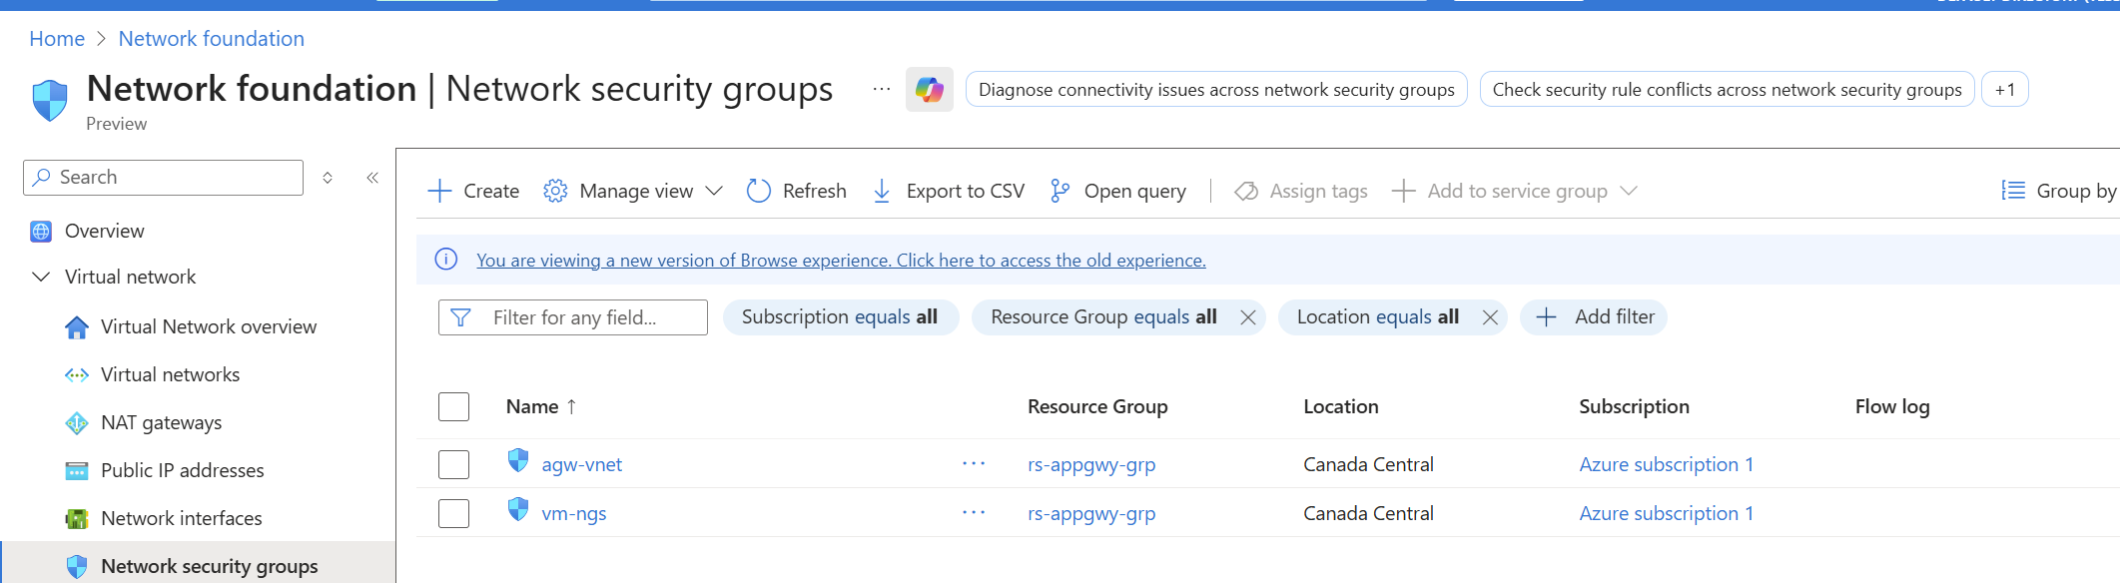

Step 5: NSG Inbound Rules
Path: NSG → Inbound security rules - Capture: - Allow HTTP 80 from AGW subnet - Allow SSH 22 from Admin IP
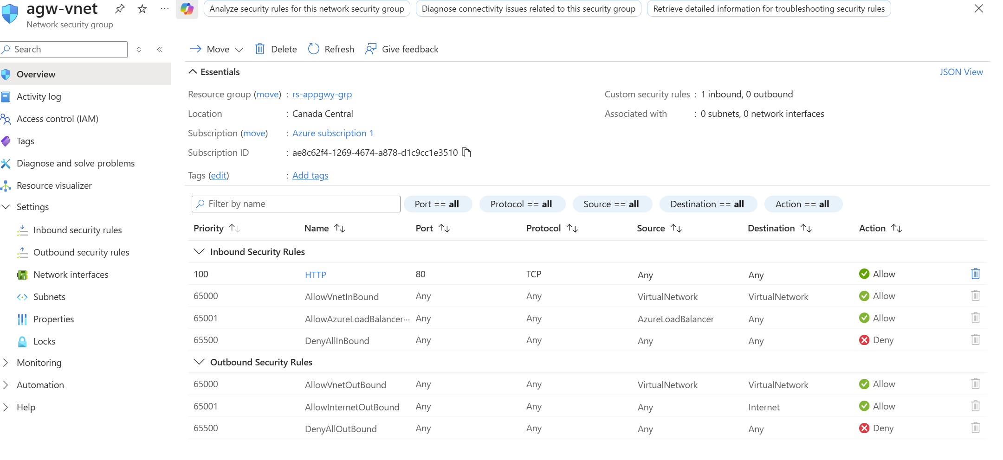
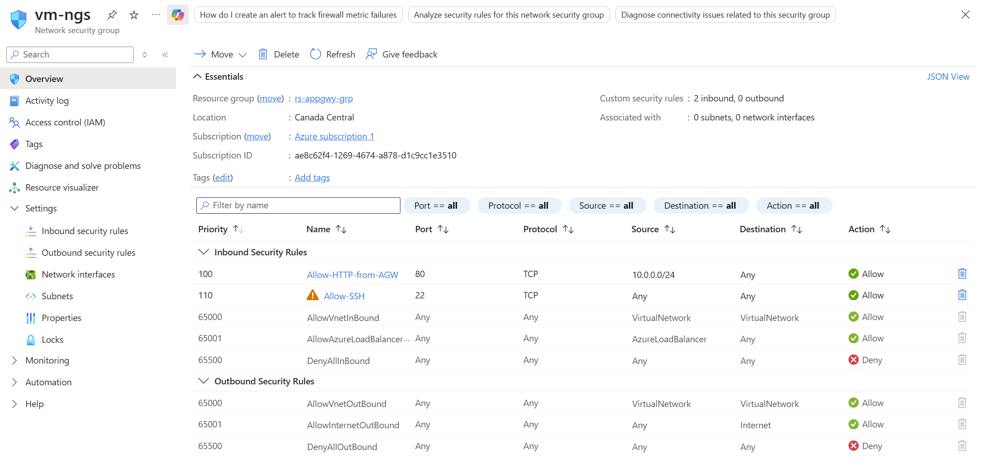

Step 6: Product VM Creation
Path: Virtual machines → Create - Capture: - VM name - Subnet: product-subnet - No public IP (recommended)
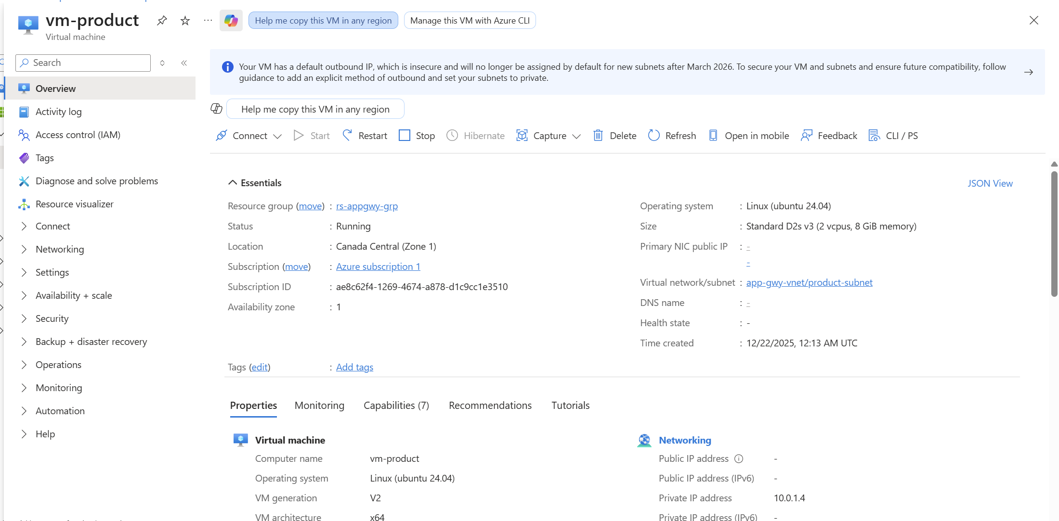

Step 7: Cart VM Creation
Path: Virtual machines → Create - Capture: - VM name - Subnet: cart-subnet
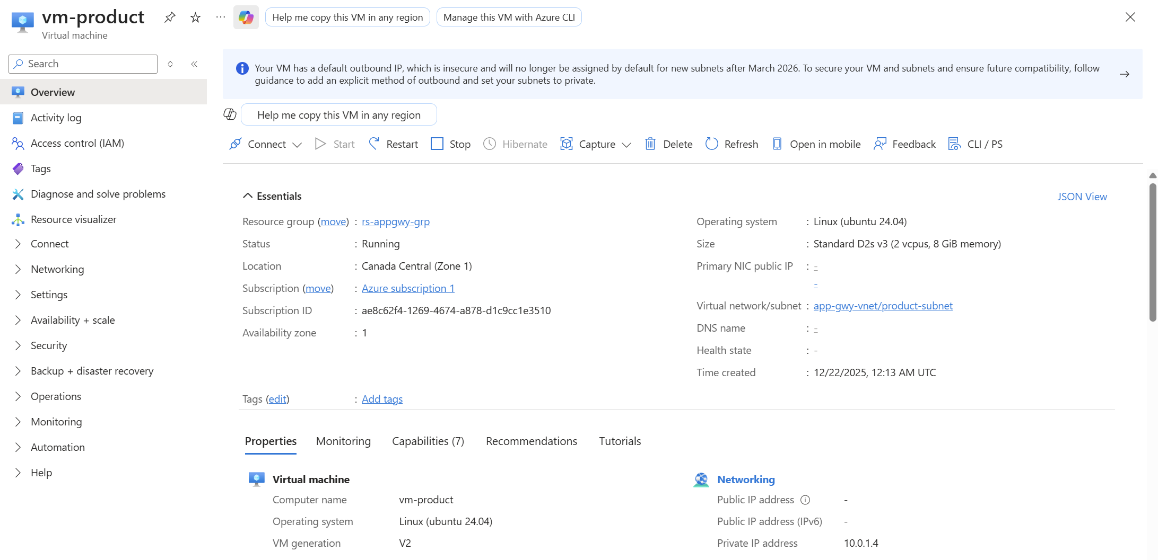

Step 8: Application Gateway Creation
Path: Application Gateways → Create - Capture: - SKU (Standard_v2 or WAF_v2) - Subnet: agw-subnet - Public IP configuration

Step 8.1: Backend Pools
Path: Application Gateway → Backend pools - Capture: - product-backend with Product VM IP - cart-backend with Cart VM IP

Step 8.2: Health Probes
Path: Application Gateway → Health probes - Capture: - Probe path and status

Step 8.3: HTTP Settings
Path: Application Gateway → HTTP settings - Capture: Port 80 configuration

Step 8.4: Path-Based Routing Rule
Path: Application Gateway → Rules - Capture: - /product/* → product-backend - /cart/* → cart-backend

Step 8.5: Backend Health (Validation)
Path: Application Gateway → Backend health - Capture: Both backends showing Healthy
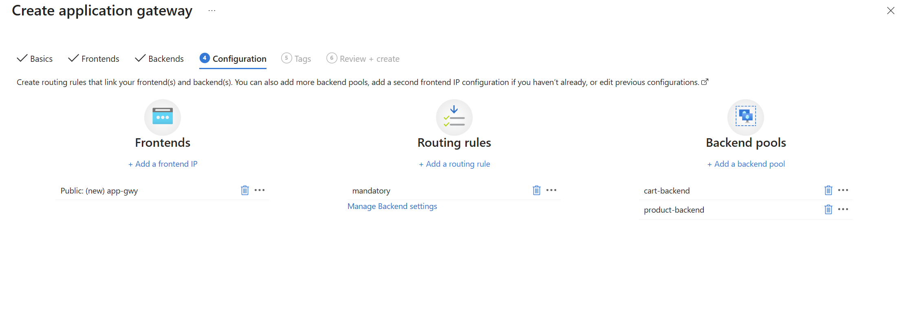
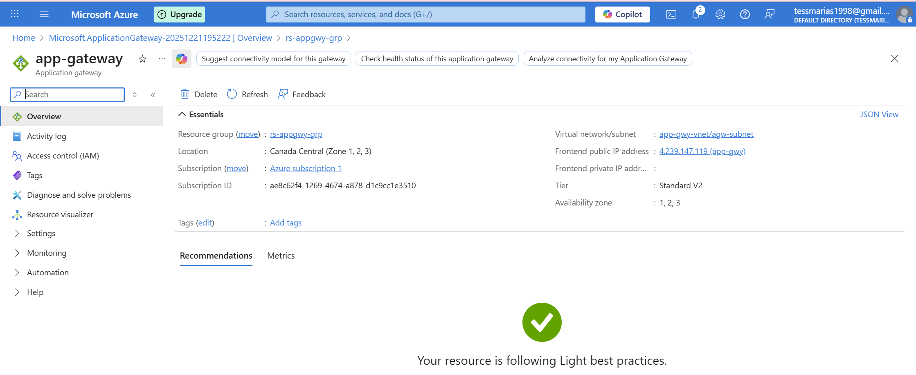

Step 14: Final Testing (Browser)
- Capture browser output:
  - http:///product
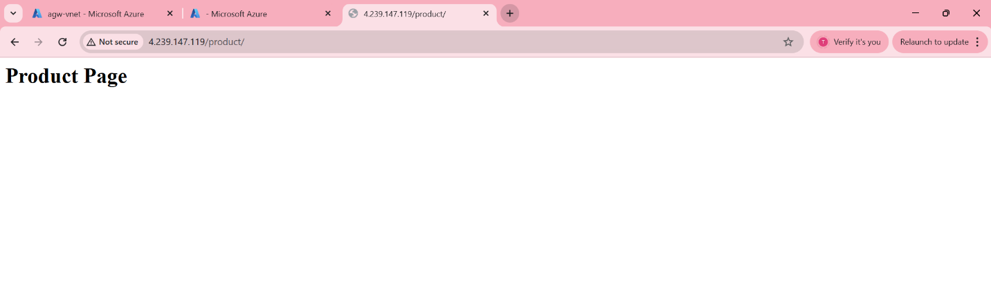
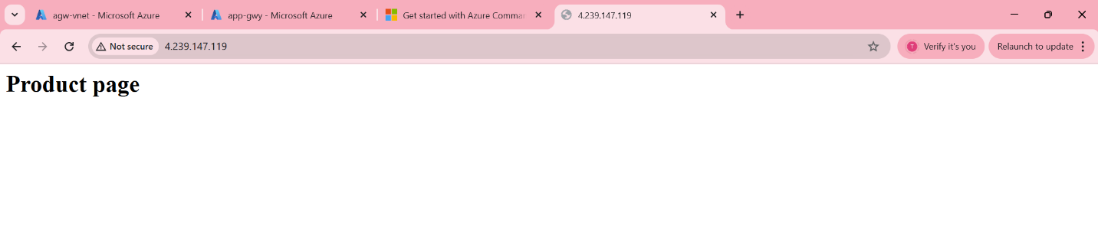
  - http:///cart

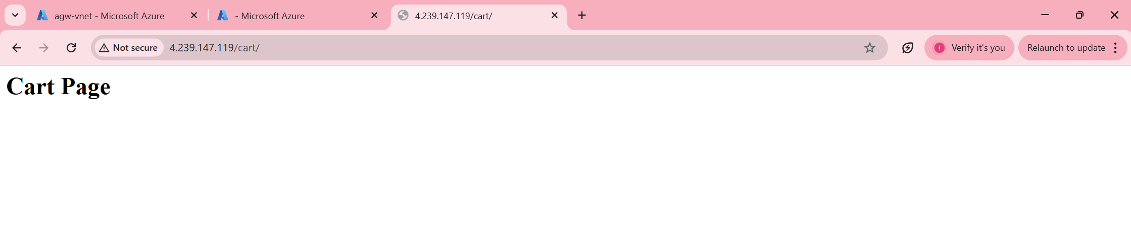
12. Architecture Diagram
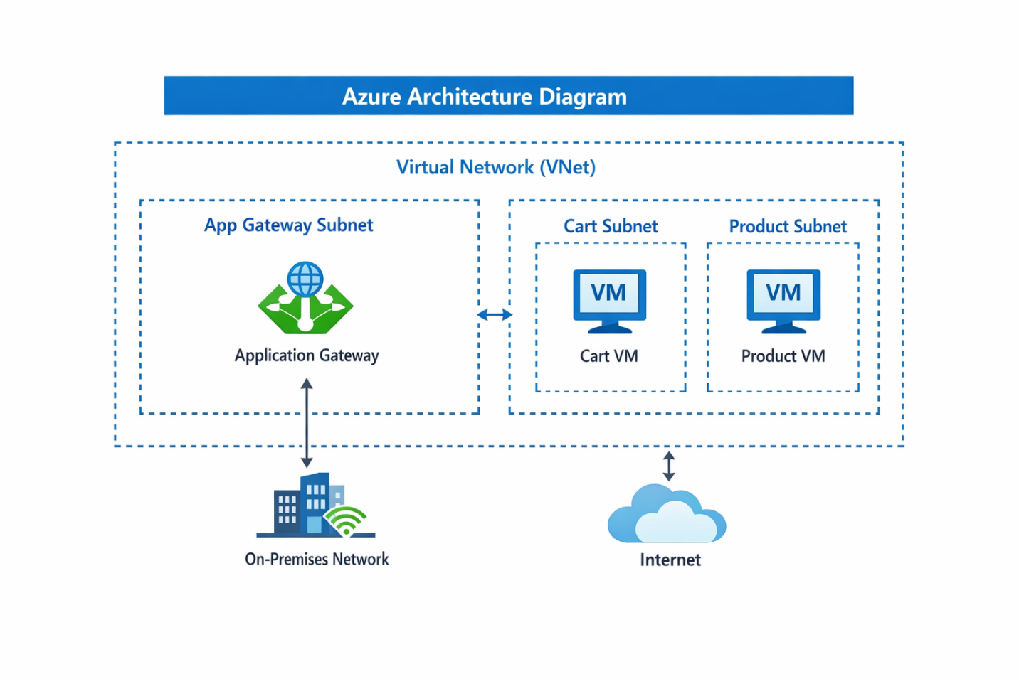

13. Conclusion
This deployment demonstrates a secure, scalable, and exam-ready Azure Application Gateway architecture using path-based routing, fully deployed and validated via the Azure Portal.

Author: George Devid
Platform: Microsoft Azure
Deployment Type: Portal-based Infrastructure

